

American International University-Bangladesh (AIUB)  
**Department of Computer Science  
Faculty of Science &Technology (FST)  
Spring 20_21**

**Section: C**

**EASY FARMING**

A software Engineering project submitted

By

|  |  |  |
| --- | --- | --- |
| Serial No. | Student Name | Student ID |
| 11 | ISTIUQ AHMAD | 18-38590-2 |

The project will be Evaluated for the following Course Outcomes

|  |  |
| --- | --- |
| Your Project will be Evaluated based on the following marking criteria | Total Marks |
|  |
| Requirements Analysis (functional, quality, and project requirements) [5Marks] |  |
| System Design (UML, UI/UX design) [5Marks] |  |
| Test and Project Management Planning [5Marks] |  |
| Submission, Completeness, Spelling, Grammar and Organization [5Marks] |  |

Submission Date: 21-04-2021

**1. PROBLEM DOMAIN**

**1.1 Background to the Problem**

Farmers are faced with issues impacting agriculture, including new challenges and opportunities every day. The basic problem of farmers is awareness. Lack of awareness about farming techniques, farming skills, seeds, fertilizers, crop management etc. Another problem is due to insufficient money farmers procrastinate everything like cultivation because it is not able to possible that every farmer has equipment of their own so they need to outsource such services. But such service provider does not provide services on credit. Then seeds, fertilizers, pesticides and insecticides provider very hardly give it on credit but they include interest silently and provides only those brands who gives them enough margins.

This problem is so important to consider because, feeding problem has a direct impact on the growth rate, production capacity and health status of the human. Feeding is a key for a profitable and sustainable farming. The cost of feeding has long been recognized as the major cost and the largest cash expense in the economy.

**1.2 Solution to the Problem**

The objective of our project is to improve our agriculture by helping the farmers. By using our system farmers will get much useful information. They will be able to know about the weather reports. They will get to know about the updated price of the things they need to know in terms of farming. They will be able to contact the bank using the app. Then can even make transactions by using the app. They can also take advice from the experts. They even can contact the city agriculture officers if needed. These are some objectives of this app.

Basically, we are going to provide some various solution in our projects to overcome above problem. Those are:

1. Weather forecast.

2. Knowing the type and strength of their farm land soil.

3. Getting update for seeds and fertilizer in fair govt. price.

4. Notification for sowing seeds in exact time.

5. Identified Crops Disease.

6. Harvesting in right time.

7. Buy farming Equipment from vendor.

8. Request for Bank loan.

9. Emergency help from Agricultural officer.

10. Basic farming knowledge.

Though there are already lot of existing solutions available including Farming. But they didn’t provide services like our proposed solution. Existing solutions provide only some few services. Which services are not so helpful for the farmers. They provide only some general problem solutions like basic knowledge of farming, weather forecast, disease of crops etc.

**2. SOFTWARE DEVELOPMENT LIFE CYCLE.**

**2.1. Process Model**

Our proposed “Easy Farming” software will help the farmers to create a platform for them to overcome from all difficulties and challenge they faced regularly. The software will initially require users to register, and it will be updated in the main database. They will be given a confirmation and they will be asked to make a log in id and password for themselves. If it is done under the given conditions, their id and password will be confirmed. After registration users can use and take information regarding their demand. The main target of user in this software will be farmers and also govt. agriculture employee, Businessman and Bank authority can use this platform. Farmers can get any kinds of help like basic farming knowledge, weather forecast, updated fertilizer and seeds price, emergency help from agriculture officers, easy bank loan and they can order any kinds of equipment, fertilizer and seeds from different places. So, we choose Agile method to develop the software.

Agile is the one kind of iterative or incremental development. Agile maximizes value throughout the development process and significantly reduces the overall risk of any given project. In agile method we work part by part. We can do our software part by part like agile method. By using Time Box, we can do our task part by part. Though Agile iteration length is 1 month, So, if we fail to complete task in one time box then we can use another time box to add remaining task. Agile method supports to deliver software in shorter timescale. It was common to test software before launch, but with Agile, testing is integrated throughout every stage of development to ensure a quality end product. Agile method helps to update services to compare with technology. In our project we need to update our services and information regularly for user basis. Flexibility is praised as one of the most beneficial reasons to use Agile. Because the methodology allows for change, there is always room for mistakes and opportunity to iterate. The most efficient and effective method of conveying information to and within a development team is face-to-face conversation. In most cases, Agile utilizes user stories to determine product features. When you create user stories, you’ll focus on solving the real needs users have, instead of developing features that could turn out useless. This agile process helps to get feedback from user which will be help to increase our software performance and services.

**2.2. Project Role Identification and Responsibilities**

Successful projects are usually the result of careful planning and the talent and collaboration of a project’s team members. A project management consists of some very important roles. These roles may vary by project. Here, we will describe Six roles- Customer, Developer, Project Manager, Project Team, Project Sponsor, Business Analyst, Project Team Lead and describe their associated responsibilities:

**Customer**

The customer is responsible for writing user stories, setting priorities and formulating the product backlog and Provides input into the original project outline. Also reviews and helps decide on proposed project changes. Customer may participate in user acceptance testing of the output delivered by the project.

**Developer**

The developer is the person who is an ordinary programmer. Writing the code and performs the entire amount of project task is done by him.

**Project Manager**

The [project manager](https://www.villanovau.com/resources/project-management/project-manager-jobs/) plays a vital role in the project, and is responsible for its successful completion. He develops a project plan and manage the team’s performance of project task. This Person responsible for planning, organizing, managing, controlling and communicating on all phases of a project. Project Manager Provides regular updates to upper management.

**Project Team**

Team member assigned full or part time to participate in project team activities. Responsible for contributing to overall project objectives and specific team deliverables. Complete individual deliverables and provide expertise. This role includes all various resources necessary to execute the project plan.

**Project Sponsor**

Sponsor makes the business decisions for the project. They also approved project budget. Also makes user resources available and approves work products. Provides regular feedback to the project team on performance versus expectations.

**Business Analyst**

The Business Analyst is responsible for investigating business systems. They develop and maintains models of business requirements. Analyzes and develops an understanding of the current state processes to ensure that the context and implications of change are understood by the department and the project team. Identifies and documents all business, technical, product and process requirements and works with the department to prioritize the requirements.

**Project Team Lead**

Provides project leadership, confirms the need within their area of responsibility, validates goals, objectives, and resources and is accountable for the overall delivery of the project. Assigned full or part time to participate in project team activities. Manages specific project plan activities and contributes to project plan development in collaboration with project manager. The team lead is responsible for product testing. The quality of the final product strongly depends on their work.

# 4. PRODUCT AND PROJECT DESCRIPTION

**System Features**

List of the system functional requirements that describes the system’s functionalities are described below.

**Functional Requirements**

**4.1 Profile**

**Functional Requirements**

1. The software shall allow user to give their valid Name, Address, Personal details, Contact info, profile picture and posts.
2. User can change his/her profile details at any time.
3. User also can delete his/her given post on profile.
4. User can logout manually from profile.

**Priority level:** High

**Pre-condition:** User must be registered.

**Cross-reference:**

**4.2 Browse and filtering:**

**Functions**:

Both type of users will be able to browse for buy and sell product. While browsing, the

users will be able to narrow down the search results using various filters.

1. Users will be able to set the minimum and maximum price range according to

their budget while browsing.

1. Users can search for specific product while buying something.
2. Users can set location for nearby shop.

**Priority Level:**  Low

**Precondition:** Login

**Cross reference:** 3

**4.3 Buy & Sell**

**Functions**:

1. Buyer can browse and make shopping.
2. Seller can post their product.
3. Buyer can select best prices similar kind of product.
4. If buyer order any product it will add automatically to the shopping cart.

**Priority Level:** High

**Precondition:** For make transaction user have to register.

**Cross reference:**

**4.4 Weather Info**

**Function:**

1. Users will get real time weather update.
2. Users can get ’Last 10 Days’ weather update from here.
3. Notice or update from Meteorological Department will be appear in weather update.

**Priority Level:** Medium

**Precondition:** User have to be connected with internet

**Cross reference:**

**4.5 Bank Loan**

**Function:**

1. Farmers can get information about bank loan.
2. Software shall allow farmers to apply for loan.
3. Farmers also can pay loan from here.
4. Bank authorities are able to help or contact with farmers for any kind of issue.

**Priority Level:** Medium

**Precondition:** Farmers have to be a verified account.

**Cross reference:** 8,9

**4.6 Basic Farming**

**Function**

1. Any kinds of user can get knowledge about farming from here.
2. Different kinds of soil, crops and fertilizer details will be given.
3. Farmers will know harvesting time and crops disease from here.
4. Farmers are able to post by taking picture or can mention problem and specialist or people can help by comment in the post.

**Priority Level:** Medium

**Precondition:**

**Cross reference:**

**4.7 Emergency Contact**

**Function**

1. If farmers need any suggestion they can get help from govt. agriculture officer.
2. Farmers can use help line.

**Priority Level:** Low

**Precondition:**

**Cross reference:**

**4.8 Verifications**

**Functions**:

1. The users are required to provide soft copy of their NID, Birth certificate, phone number and documents to our admins during registration.
2. The information provided by users will be verified by the system and a confirmation of that will be sent to the respective users by notification.
3. If any information is found to be invalid or false then the users will be notified and the transaction will be failed.

**Priority Level:**  High

**Precondition:** Proper documents need to be submitted by users before registration.

**Cross reference:** 1

**4.9 Payment:**

After clicking on the payment option user has to pay by choosing a payment method. Payment methods can be mobile banking, debit card or cash

**Functional Requirements:**

1. System will ask for preferred mobile banking platform. then followed by account no and password. Then the system will generate receipts.
2. If the user chooses debit card then the system will ask for account no and password. Verify with the bank about given information. Then proceed to generate receipts.
3. If payment was successful, user will get message in mobile and also get notification.

**Priority Level:**  High

**Precondition:** Verification

**Cross reference:** 3,5,8

**4.10 Home**

**Functions**:

1. Software will bring user in home window.
2. It will refresh the home window.

**Priority Level:**  High

**Precondition:** User have to be login.

**4.11 Notification**

**Functions**:

1. Notifications inform the user about an event and encourage them to take action.
2. The farmers will get notified by weather update.
3. Updated fertilizer price from govt. will be appear in notification.
4. Farmers can get offer and promo from vendor by notifications.
5. Important notice will be given by notification.
6. If users are not log in to the system but they will get notification.

**Priority Level:**  High

**Precondition:** User have to be connected with internet.

**4.12 Menu**

**Function:**

1. User can select language.
2. Users can Change Password.
3. Users can give feedback and review for this software.
4. User will get FAQ option from here.

**Priority Level:** High

**Precondition:** Login

**Cross reference:** 1,4,5

**Non-Functional Requirements:**

**1. Performance requirements**

The application shall be based on java and has to be able to run on any platform. The initial loading time of the application will depend on the operating system and internal hardware.

**2. Safety requirements**

The database might crash at any time due to virus or operating system failure. Therefore, it is required to take backup of the database on a daily basis.

**3. Security Requirement**

This project provides a genuine security to all those individuals who are having their account on the database. This is very important aspect of the design and should cover areas of hardware reliability, fallback procedures, physical security of data and provision for detection of fraud and abuse.

**Project Requirements:**

**1.** Farmers, vendor, bank authority, govt. employee and normal user will use the same application but will have access to different features.

**2.** The size of the application must not exceed 100 MB to be storage friendly.

**3.** The database must have the feature to extend its capacity so that it can accommodate the increasing number of users.

**4.** The web version of the system should be developed in a way to support multiple browsers like Chrome, Firefox, Safari, Opera etc.

**Use Case Diagram**

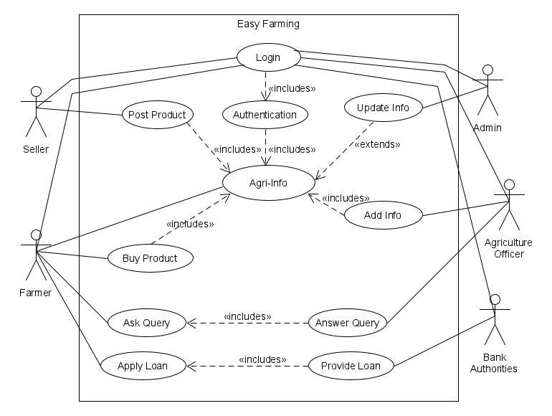

**Activity Diagram**

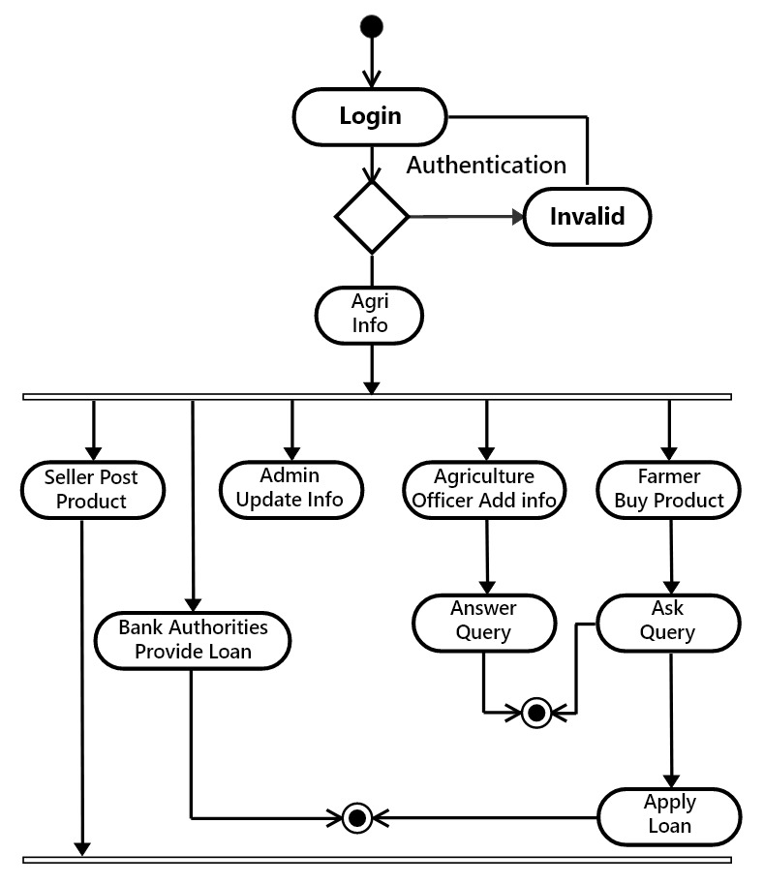

**Class Diagram**

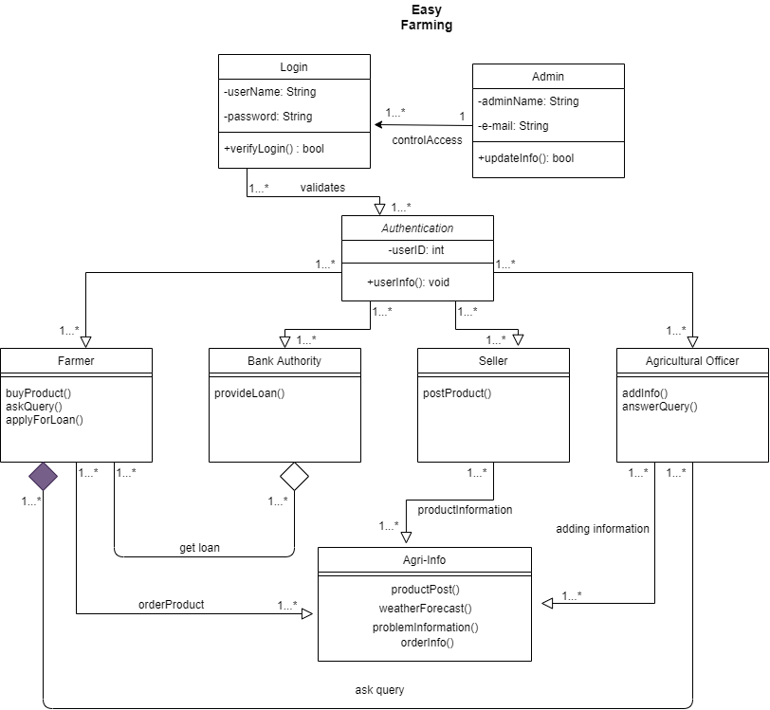

**Sequence Diagram**

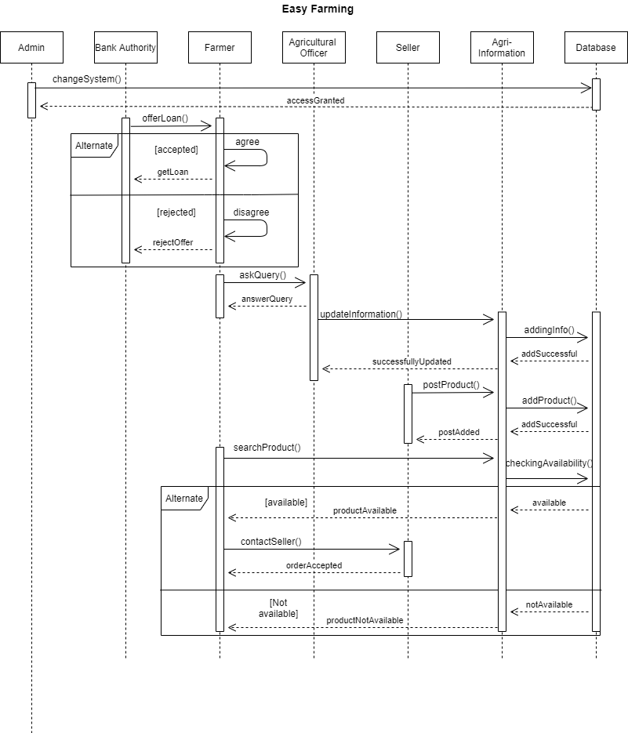

**ER Diagram**

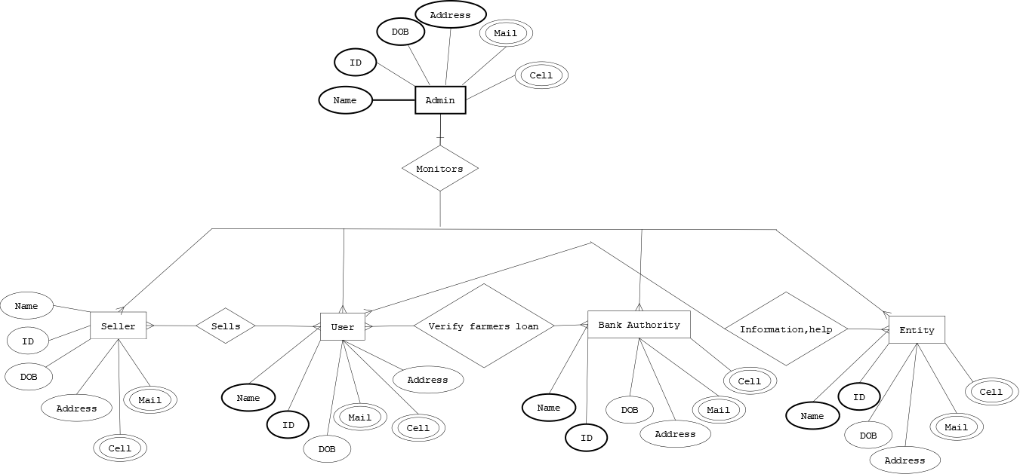

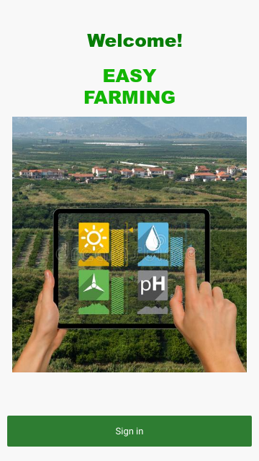**UI and UX Design:**

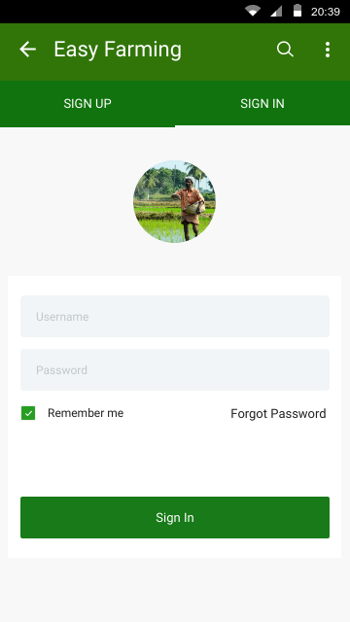

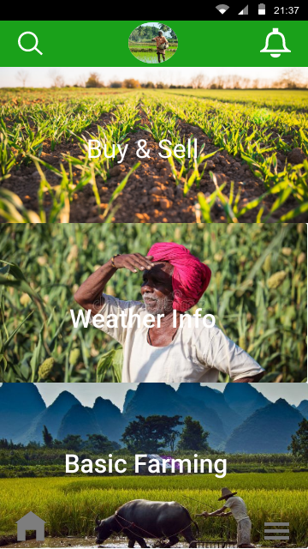 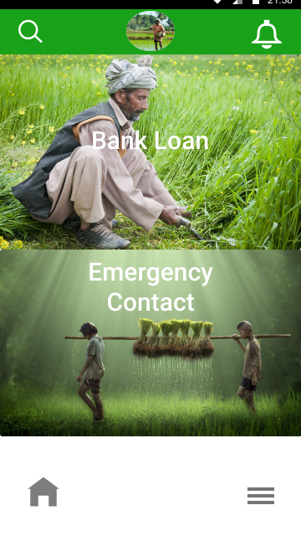

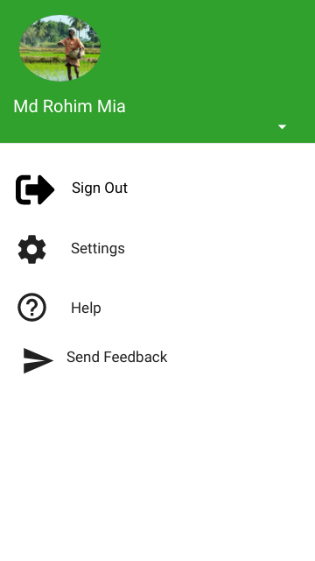 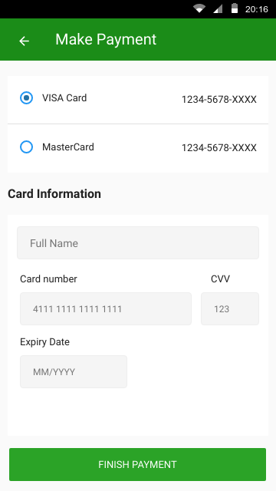

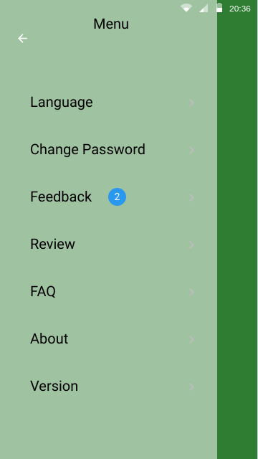

**Test Case:**

|  |  |  |  |  |  |
| --- | --- | --- | --- | --- | --- |
| Project Name: Easy Farming | | | Test Designed by: | | |
| Test Case ID: 3 | | | Test Designed date: | | |
| Test Priority: High | | | Test Executed by: | | |
| Module Name: Browsing and filtering | | | Test Execution date: | | |
| Test Title: Browse through the posts and filter according to user’s choice | | | | | |
| Description: Test browsing and filtering features | | | | | |
| Precondition (If any): User must be logged in to view the “Explore” page | | | | | |
| Test Steps | Test Data | Expected Results | | Actual Results | Status (Pass/Fail) |
| 1. Click on filter icon 2. Set the parameters according to user’s choice and select preferred additional features 3. Click on “Show results” button | Location: Dhaka  Min Price: Tk 500  Max price: Tk 1200 | A product from Dhaka and in the price range of Tk 500-1200 will be show. | | As expected. | Pass. |
| Post Condition: User is able to see posts that are according to their filter | | | | | |

|  |  |  |  |  |  |
| --- | --- | --- | --- | --- | --- |
| Project Name: Easy Farming | | | Test Designed by: | | |
| Test Case ID: 4 | | | Test Designed date: | | |
| Test Priority : High | | | Test Executed by: | | |
| Module Name: Buy & Sell | | | Test Execution date: | | |
| Test Title: Select Buy & Sell | | | | | |
| Description: Test the Buy & Sell function. | | | | | |
| Precondition (If any): User must have valid user account and authentic documents | | | | | |
| Test Steps | Test Data | Expected Results | | Actual Results | Status (Pass/Fai) |
| 1. Select Buy & Sell from the drop down menu in the “Home” page. |  | Only product will be show. | | As expected. | Pass |
| Post Condition: Post that are only Buy & Sell will be visible | | | | | |

|  |  |  |  |  |  |
| --- | --- | --- | --- | --- | --- |
| Project Name: Easy Farming | | | Test Designed by: | | |
| Test Case ID: 5 | | | Test Designed date: | | |
| Test Priority: High | | | Test Executed by: | | |
| Module Name: Weather update | | | Test Execution date: | | |
| Test Title: Checking weather update. | | | | | |
| Description: Test real time weather update. | | | | | |
| Precondition (If any): User must be logged in to view the “Home” page | | | | | |
| Test Steps | Test Data | Expected Results | | Actual Results | Status (Pass/Fail) |
| 1. Select weather update function from the drop down menu in the “Home” page. |  | Real time weather update will be show. | | As expected. | Pass. |
| Post Condition: User is able to see real time weather update. | | | | | |

|  |  |  |  |  |  |
| --- | --- | --- | --- | --- | --- |
| Project Name: Easy Farming | | | Test Designed by: | | |
| Test Case ID: 6 | | | Test Designed date: | | |
| Test Priority: High | | | Test Executed by: | | |
| Module Name: : Test Farmers verification for loan | | | Test Execution date: | | |
| Test Title: Testing verification by the system | | | | | |
| Description: Checks whether the verification done by the system is valid | | | | | |
| Precondition (If any): Submission of the documents by the farmers | | | | | |
| Test Steps | Test Data | Expected Results | | Actual Results | Status (Pass/Fail) |
| 1. User submits their NID, phone number, Birth certificate and property documents | **NID**: 8456564888  **Phone number**: 0123456789  **Birth certificate**: 123456asdgfh  **Property Details** | Information valid | | As expected | Pass |
| Post Condition: : User is informed that the information that they provided is valid and they can now proceed to use the other functions of the software | | | | | |

|  |  |  |  |  |  |
| --- | --- | --- | --- | --- | --- |
| Project Name: Easy Farming | | | Test Designed by: | | |
| Test Case ID: 7 | | | Test Designed date: | | |
| Test Priority: High | | | Test Executed by: | | |
| Module Name: Test Payment | | | Test Execution date: | | |
| Test Title: Payment by customer when buying something | | | | | |
| Description: Test payment process | | | | | |
| Precondition (If any): Customer must have verified documents | | | | | |
| Test Steps | Test Data | Expected Results | | Actual Results | Status (Pass/Fail) |
| 1. Go to “Make Payment” page 2. Select type of payment 3. If mobile banking or card is used then the user must provide account number and password. | **Account**: 89891164468  **Password**:1234 | Transaction is successful | | As expected | Pass |
| Post Condition: Customer will be provided with a receipt for online banking and card payment. | | | | | |

|  |  |  |  |  |  |
| --- | --- | --- | --- | --- | --- |
| Project Name: Easy Farming | | | Test Designed by: | | |
| Test Case ID: 8 | | | Test Designed date: | | |
| Test Priority : Medium | | | Test Executed by: | | |
| Module Name: Feedback and review | | | Test Execution date: | | |
| Test Title: Test the review and feedback system | | | | | |
| Description: Test review and feedback of the software | | | | | |
| Precondition (If any): Must be a valid user that already used the software. | | | | | |
| Test Steps | Test Data | Expected Results | | Actual Results | Status (Pass/Fail) |
| 1. Click on “Feedback” 2. Write the review in the comment section 3. Click on “Submit” | **Comment**: “The software is very user friendly” | Review submitted | | As expected | Pass |
| Post Condition: The review will be visible to other users in the profile. | | | | | |